- Course Code- ENCS351
- Course Name – Operating system
- Program Name: B.Tech. CSE- AI ML

- Student Name: SHUBHAM
- Roll No. 2301730100
- GitHub Repository Link : https://github.com/shubham055555/OS-ASSIGNMENT.git








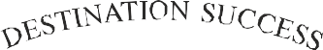


Problem Title:
System Startup, Process Creation, and Termination Simulation in Python

Problem Statement:
Modern operating systems are responsible for initializing system components, creating processes, managing execution, and gracefully shutting down. This lab aims to simulate these core concepts using Python, helping students visualize how

processes are handled at the OS level. The focus is on creating a simplified startup mechanism that spawns multiple processes and logs their lifecycle using the multiprocessing and logging modules. This hands-on simulation enhances conceptual clarity and promotes coding proficiency in scripting real-world OS behavior.

Tools/Technology Used:
- Python 3.x
- multiprocessing module
- time module
- logging module

Learning Objectives:
- Upon completing this lab, students will be able to:
- Understand the concepts of system booting, process creation, and termination.
- Develop Python scripts using multiprocessing and logging modules.
- Simulate system behaviour using programming constructs.

Assignment Tasks:
- Write a Python script to simulate a basic system startup sequence.
- Use the multiprocessing module to create at least two child processes that perform dummy tasks.
- Implement proper logging to track process start and end times.
- Generate a log file (process_log.txt) to reflect system-like behavior.
- Submit the Python script and log file along with a short report explaining your implementation.

Sub-Tasks:

- Sub-Task 1: Initialize the logging configuration to capture timestamped messages.

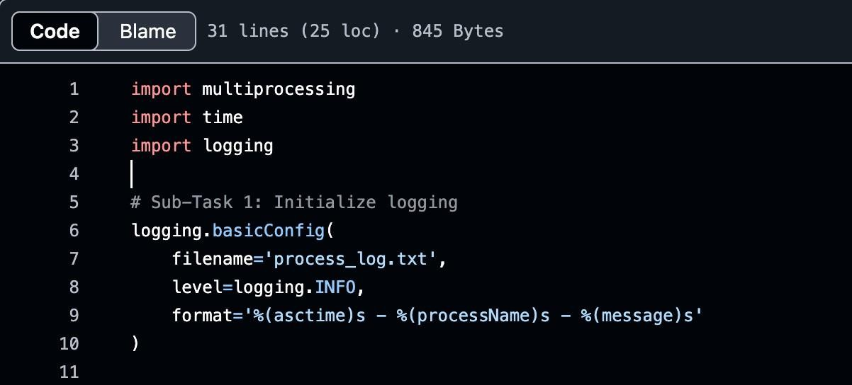

- Sub-Task 2: Define a function that simulates a process task (e.g., sleep for 2 seconds).
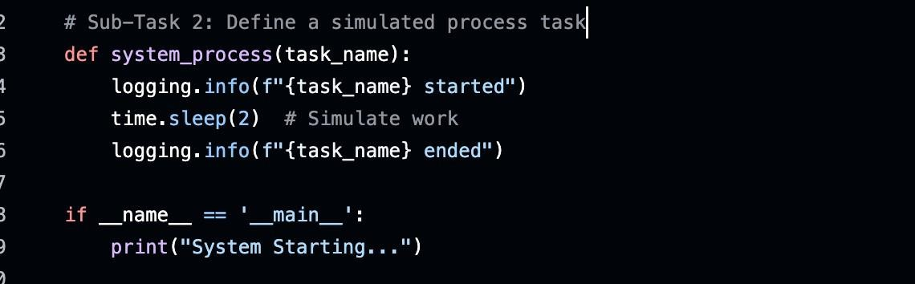

- Sub-Task 3: Create at least two processes and start them concurrently.
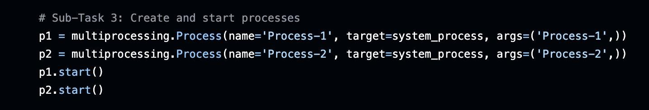
- Sub-Task 4: Ensure proper termination and joining of processes, and verify the output in the log file.

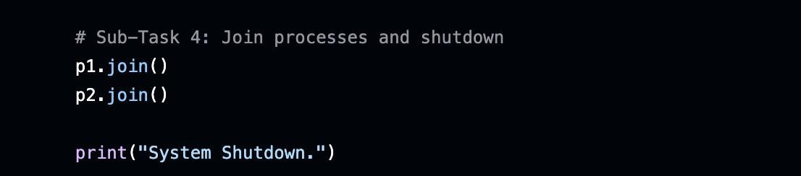

Program Code with Explanation:
The following Python script simulates a simple system startup. It creates a few dummy processes which perform simple tasks. Each process logs its start and end, and the logger records the process flow, simulating system behavior.

Code:
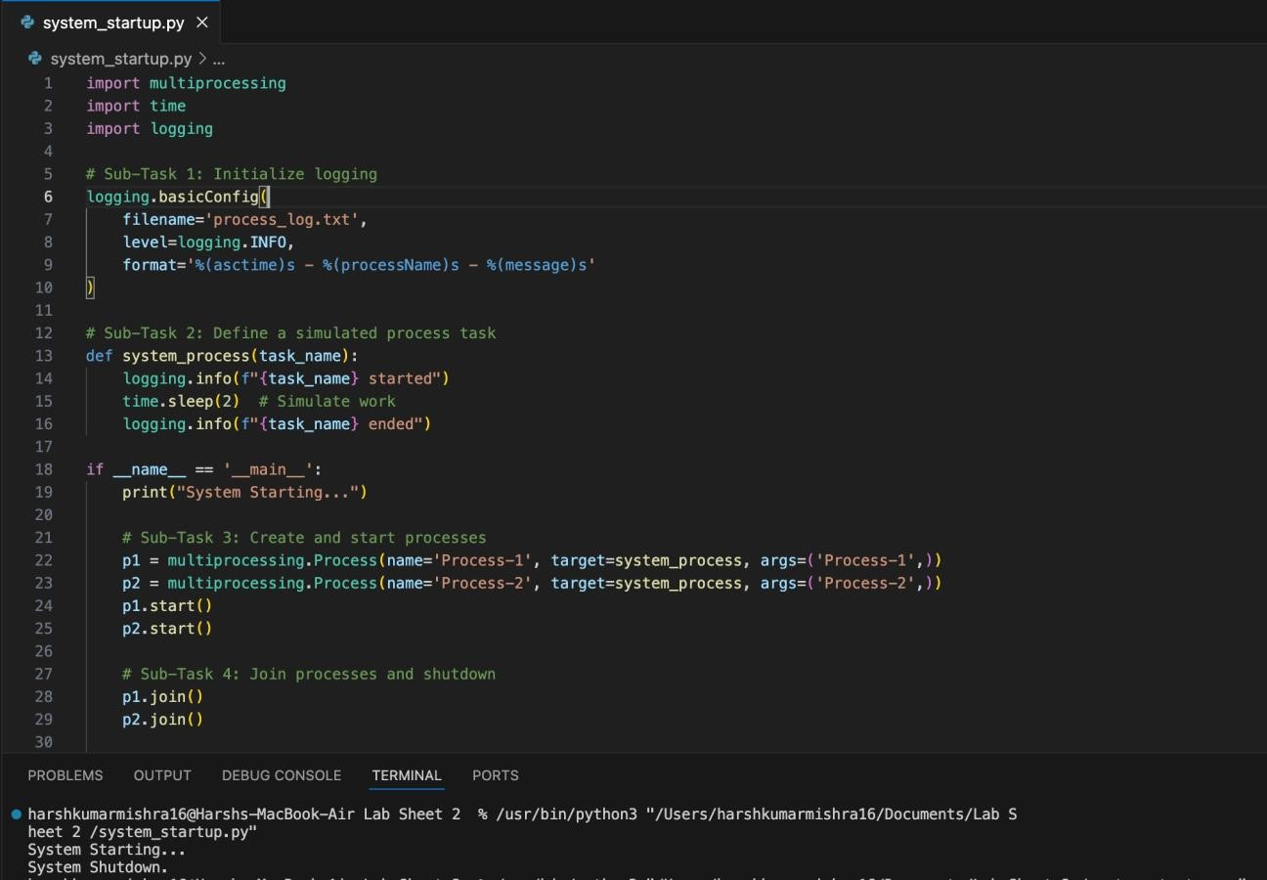

Expected Output:
  - The terminal displays 'System Starting...' and 'System Shutdown.'
  - A log file 'process_log.txt' is generated which records the start and end of each process.

